Topic 1: Basic SELECT with WHERE

Lab 1.1: SELECT * FROM Users WHERE name LIKE 'S%';

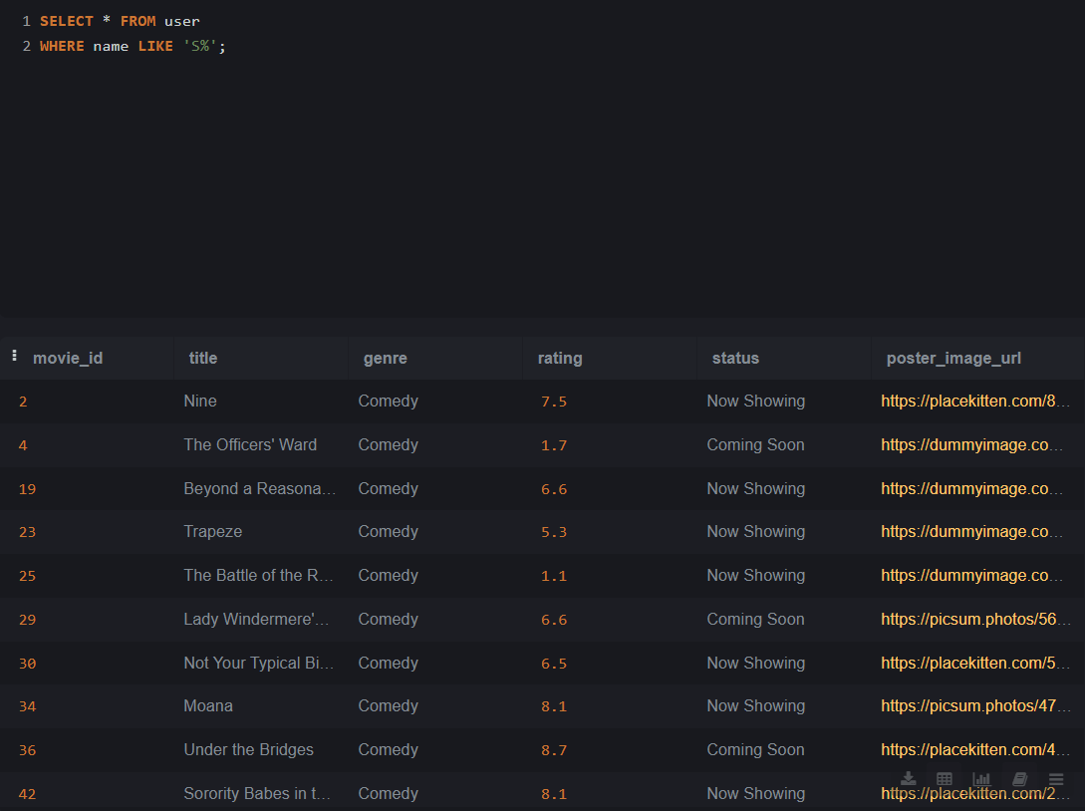

Lab 1.2: SELECT * FROM Movies WHERE genre = 'Comedy';

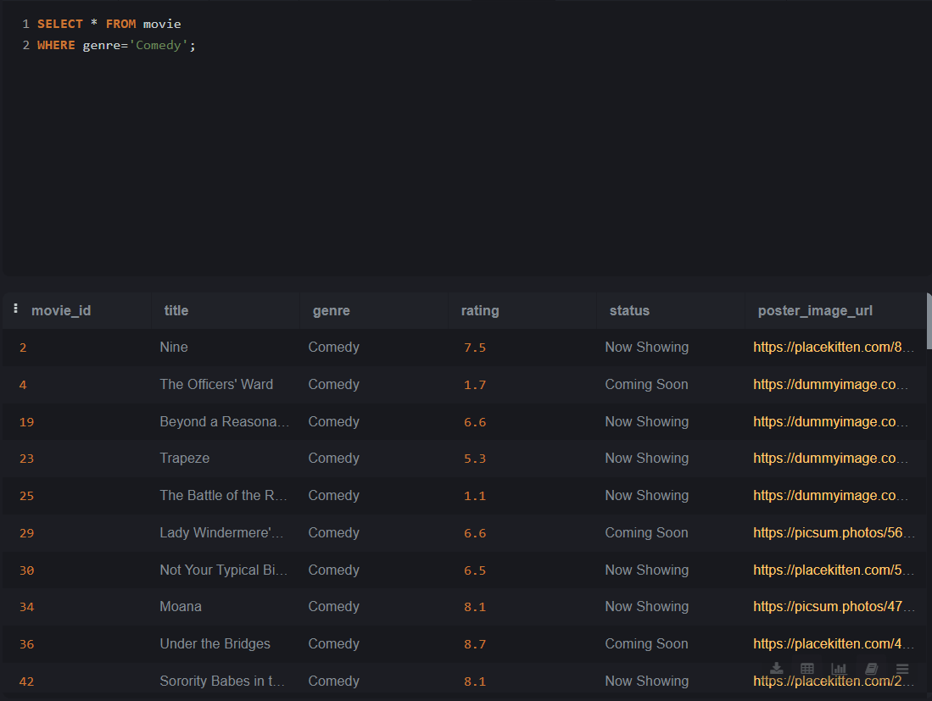

Lab 1.3: SELECT booking_id, user_id, total_cost FROM Bookings WHERE user_id = 102;

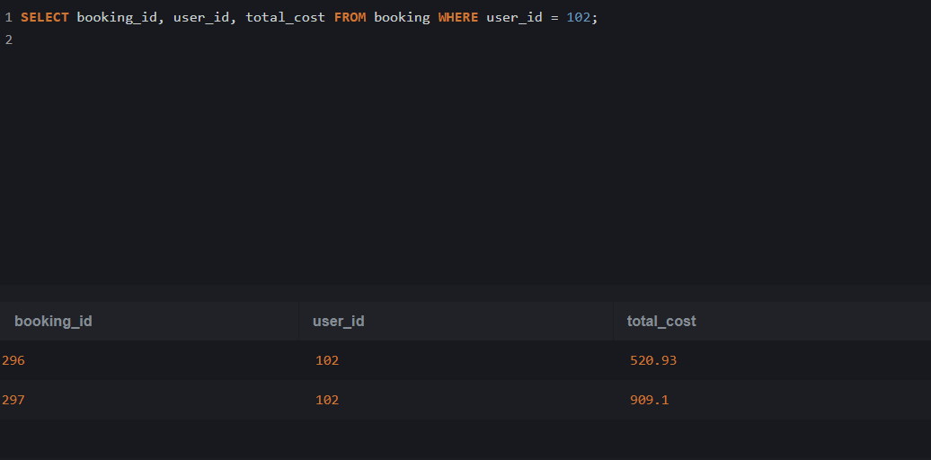

Topic 2: SELECT with WHERE using Operators

Lab 2.1: SELECT name FROM Movies WHERE rating > 4.0;

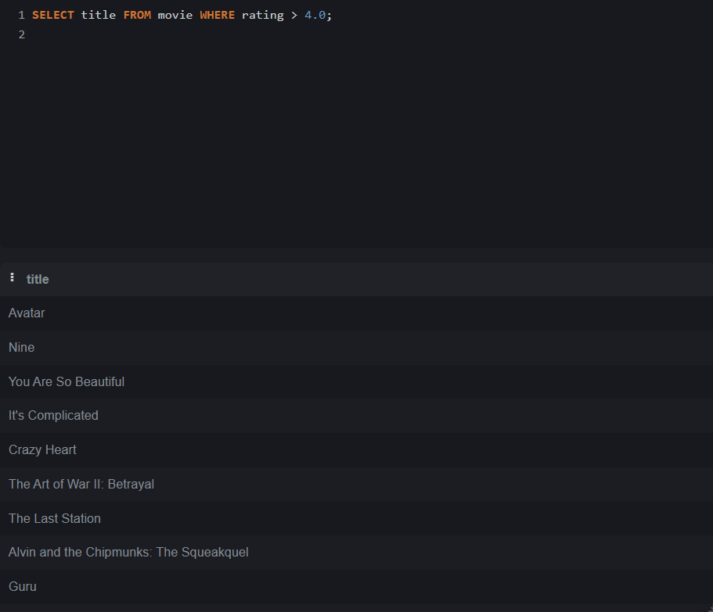

Lab 2.2: SELECT * FROM Bookings WHERE total_cost> 400;

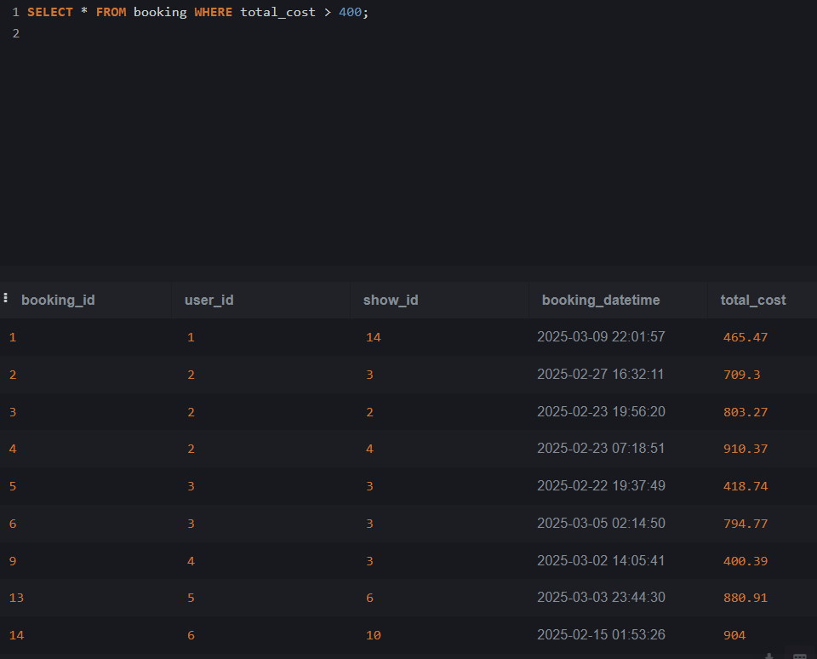

Topic 3: SELECT with WHERE using AND/OR

Lab 3.1: SELECT * FROM Show WHERE movie_id = 3 AND show_datetime > '2025-04-20';

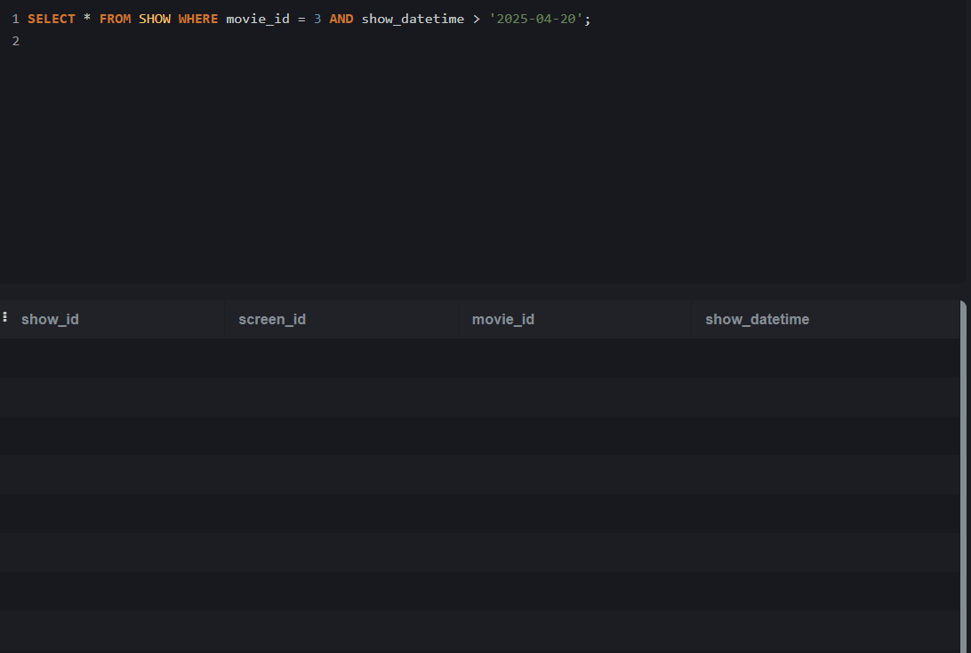

Lab 3.2: SELECT * FROM booking WHERE total_cost > 500 OR booking_datetime > '2025-04-01';

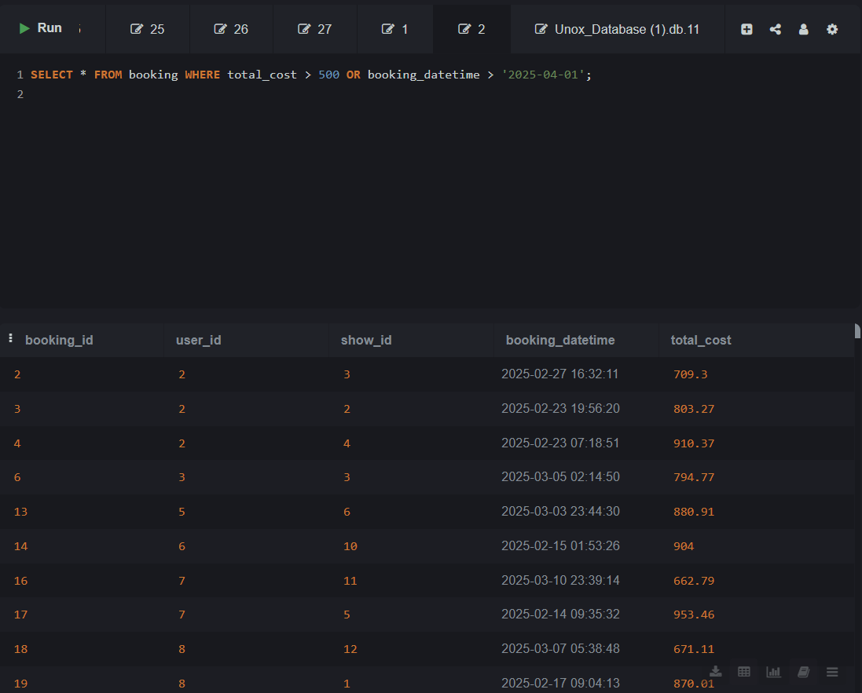

Topic 4: SELECT with WHERE and NOT

Lab 4.1: SELECT * FROM FoodItems WHERE is_combo != 1;

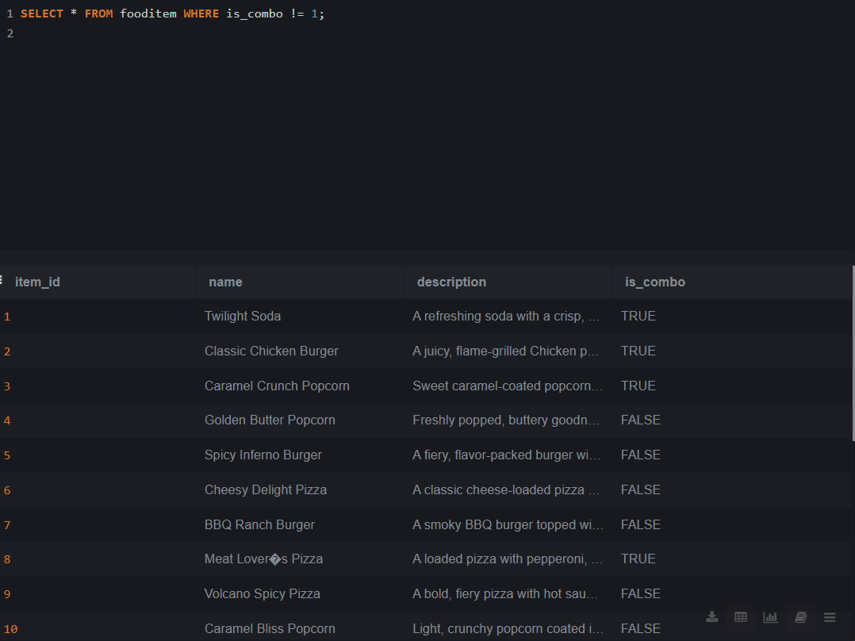

Lab 4.2: SELECT * FROM movie WHERE status != 'Inactive';

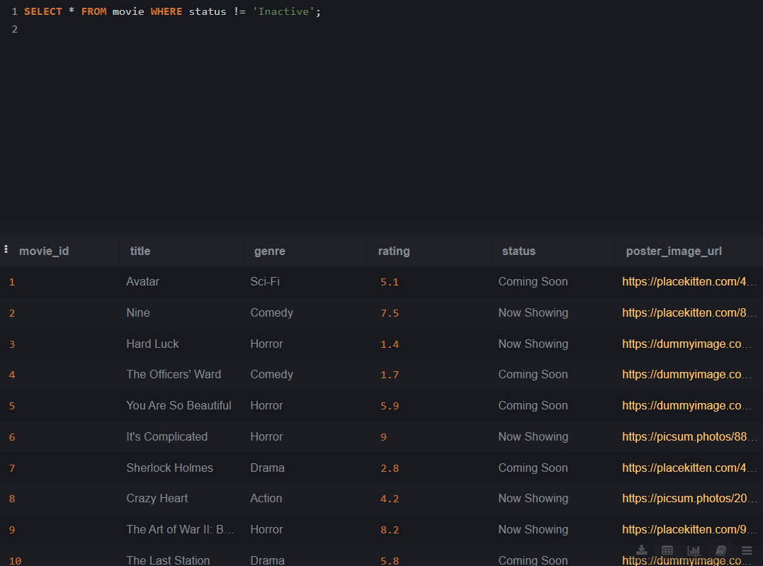

Topic 5: SELECT with WHERE and BETWEEN

Lab 5.1: SELECT * FROM fooditemsize WHERE rate BETWEEN 150 AND 300;

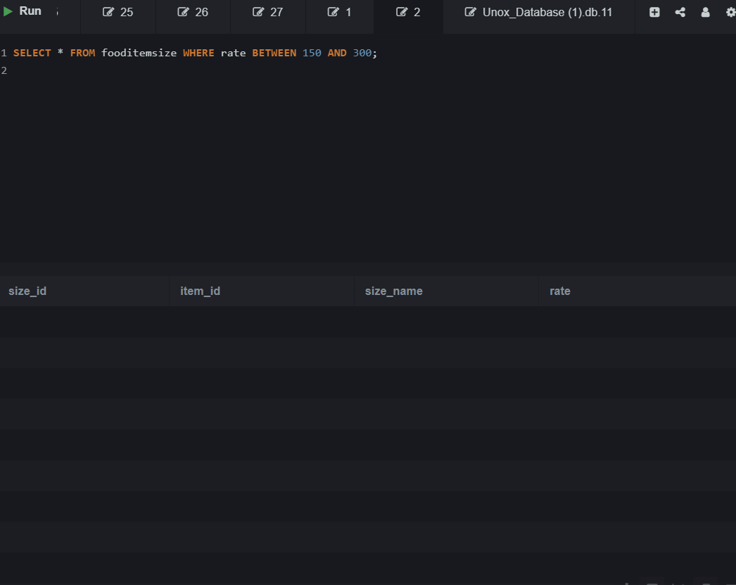

Lab 5.2: SELECT * FROM TicketBookings WHERE booking_date BETWEEN '2025-04-01' AND '2025-04-10';

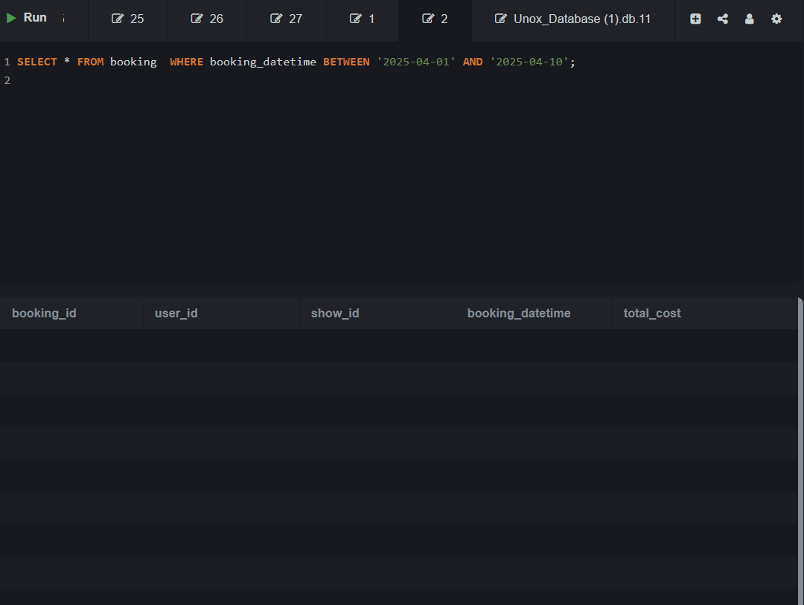

Topic 6: SELECT with WHERE and IN

Lab 6.1: SELECT * FROM fooditem WHERE name IN ('Vintage Cola', 'Sweet & Salty Popcorn', 'Fiesta Nachos');

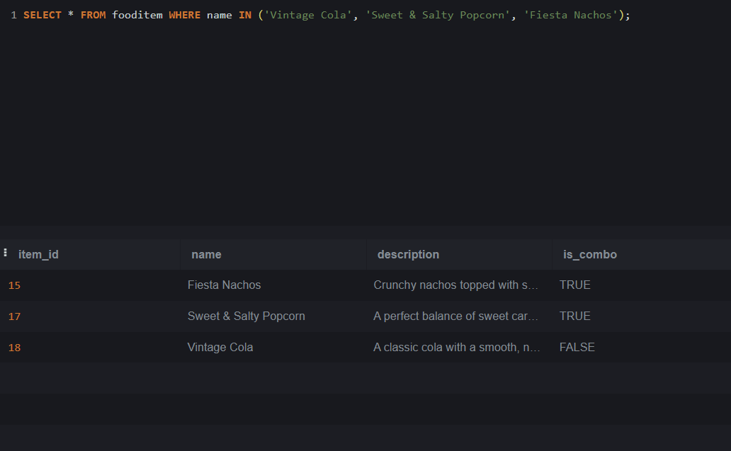

Lab 6.2: SELECT * FROM Bookings WHERE user_id IN (101, 103, 105);

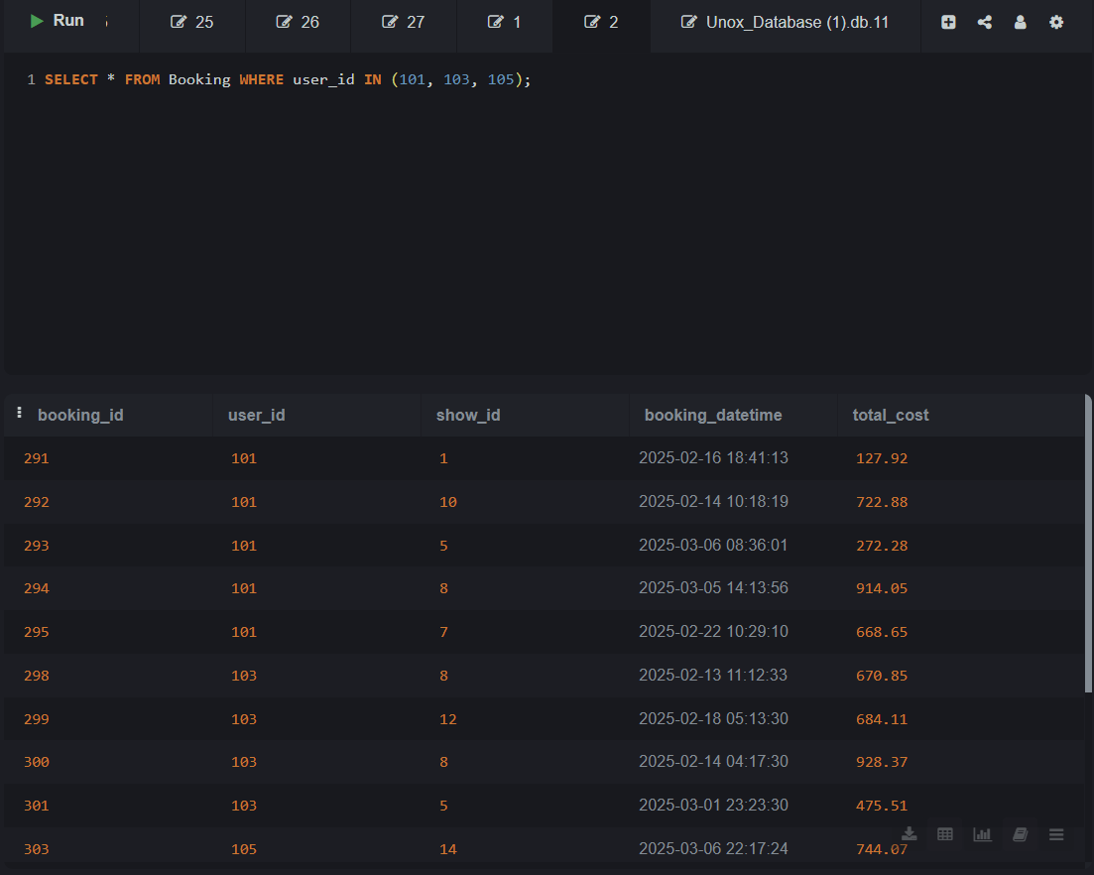

Topic 7: SELECT with WHERE and LIKE

Lab 7.1: SELECT email FROM Users WHERE email LIKE '%yahoo%';

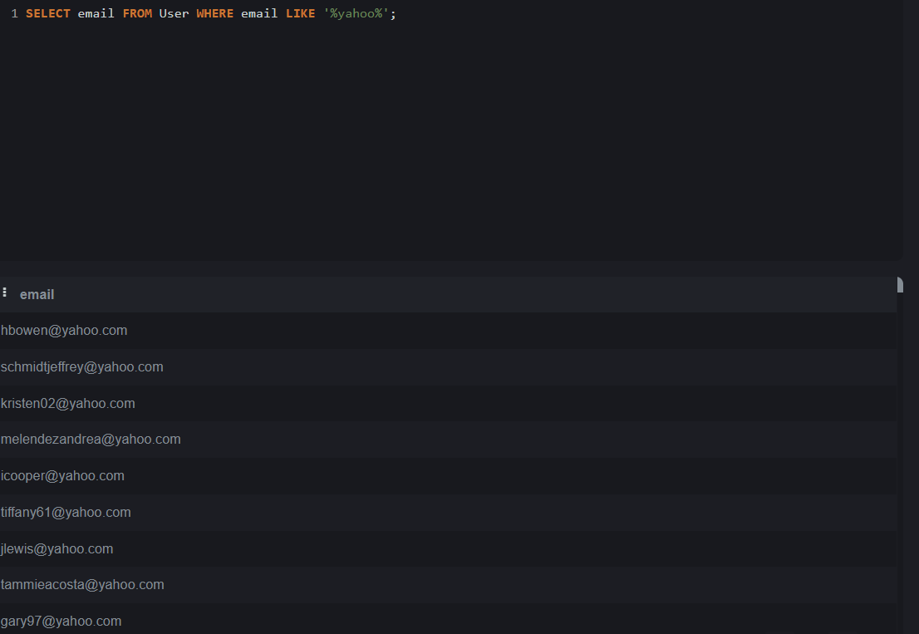

Lab 7.2: SELECT * FROM Movies WHERE title LIKE 'T%';

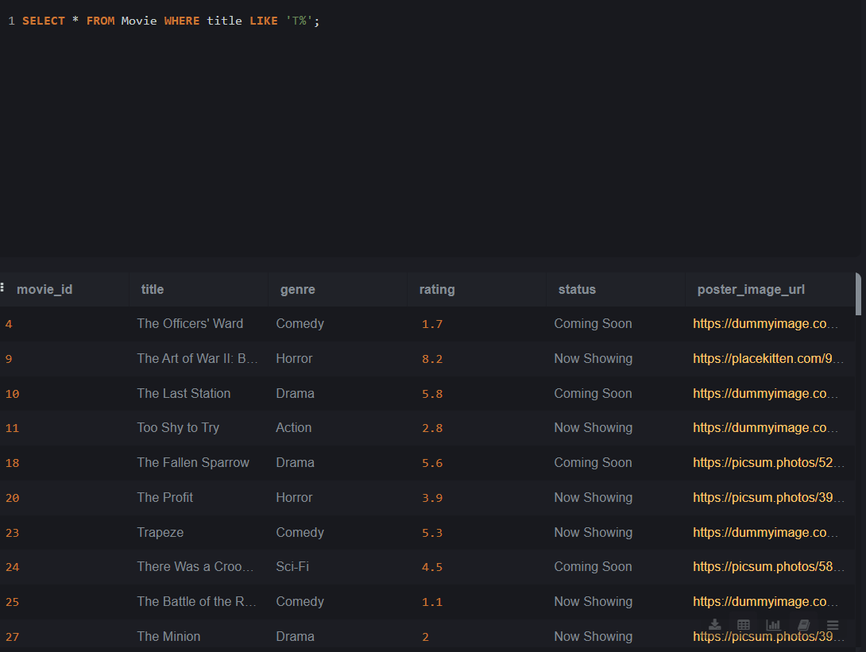

Topic 8: SELECT with ORDER BY

Lab 8.1: SELECT * FROM Movies ORDER BY rating DESC;

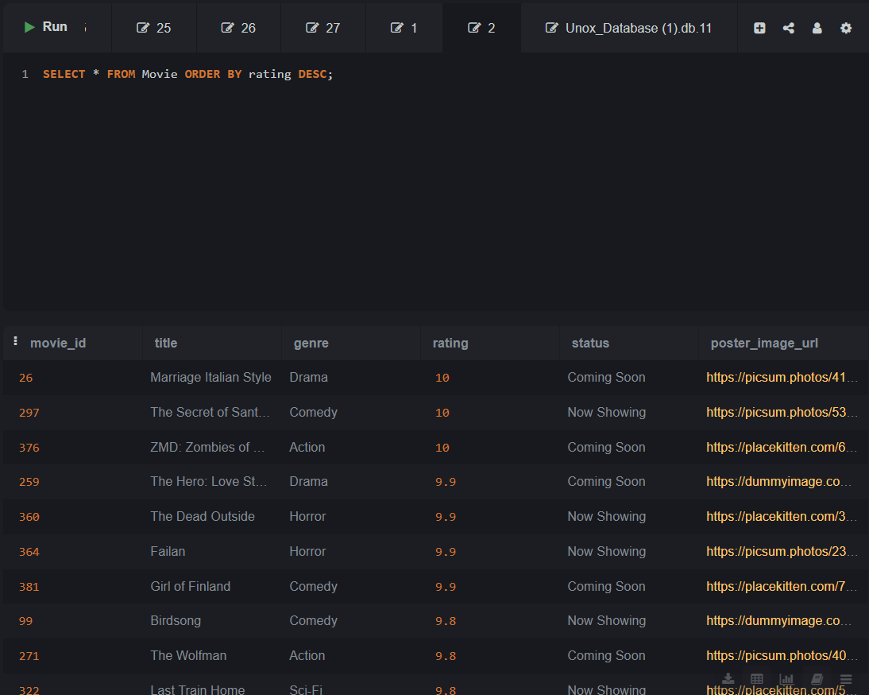

Lab 8.2: SELECT * FROM Shows ORDER BY show_datetime ASC;

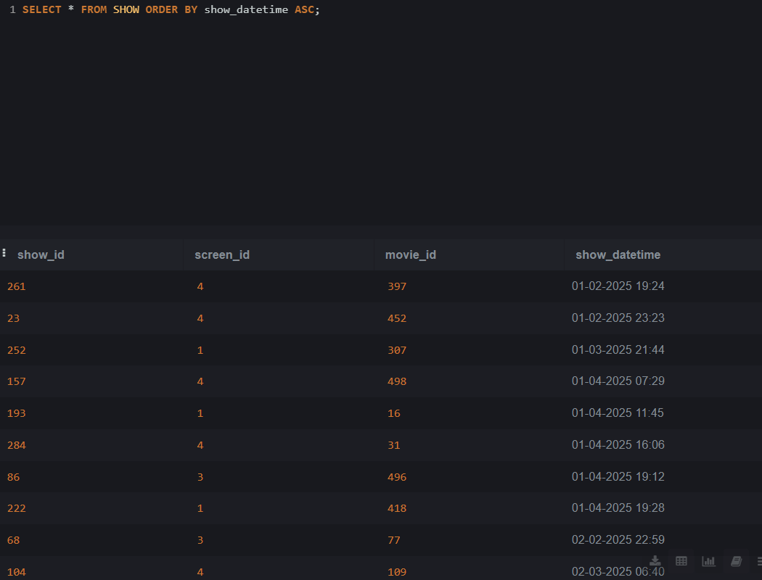

Topic 9: SELECT with ALIAS

Lab 9.1: SELECT name, rating AS "Movie Rating" FROM Movies;

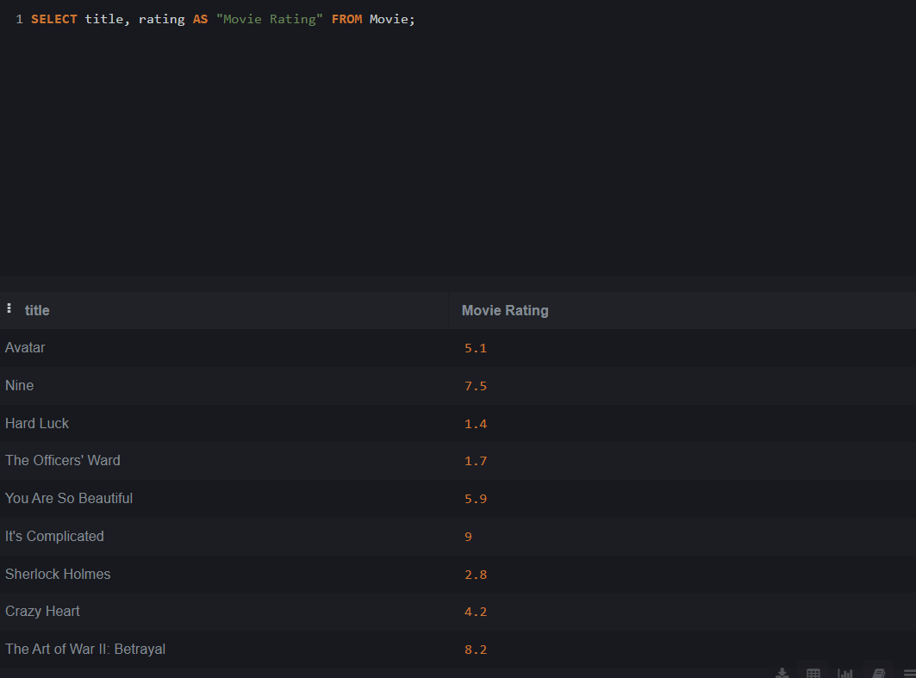

Lab 9.2: SELECT screen_name, class_type AS "Screen Class" FROM Screens;

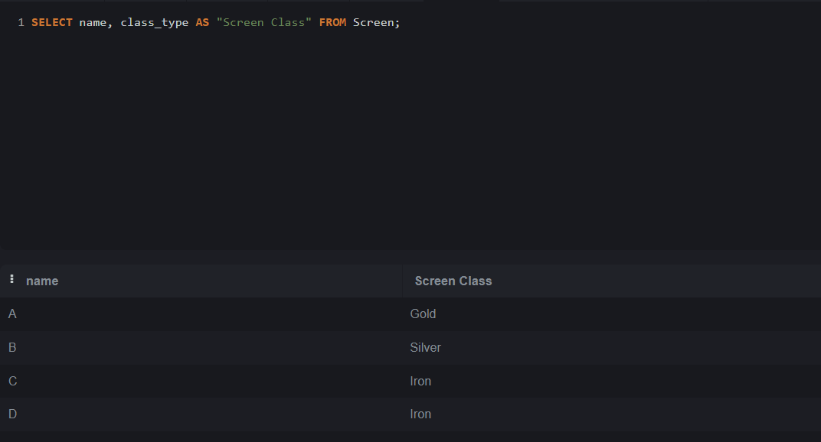

Topic 10: SELECT with LIMIT and OFFSET

Lab 10.1: SELECT * FROM FoodItem LIMIT 5;

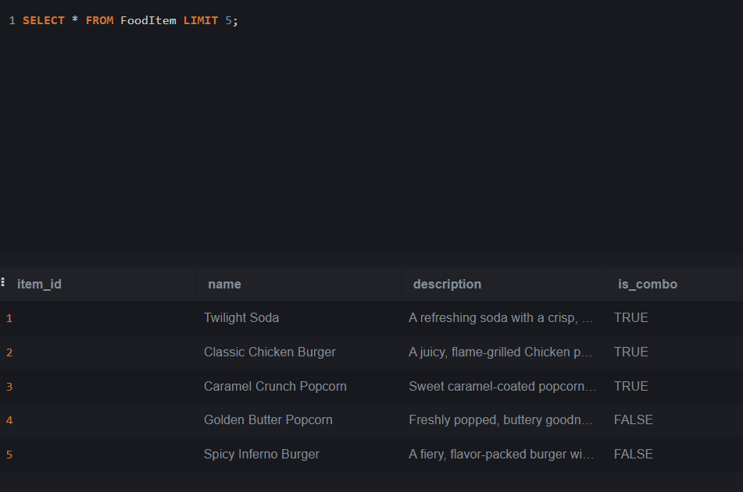

Lab 10.2: SELECT * FROM Bookings ORDER BY booking_datetime DESC LIMIT 5 OFFSET 3;

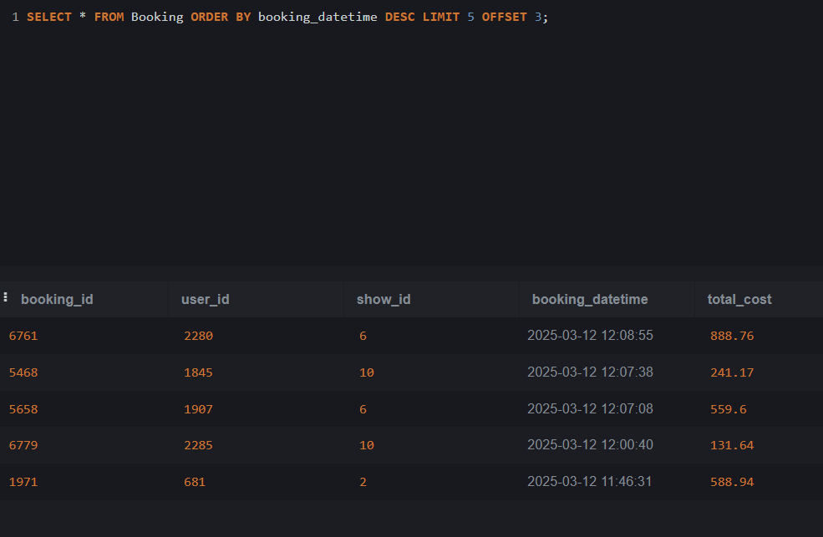

Topic 11: SELECT with Aggregate Functions

Lab 11.1.1: SELECT user_id, COUNT(*) AS booking_count FROM Bookings GROUP BY user_id;

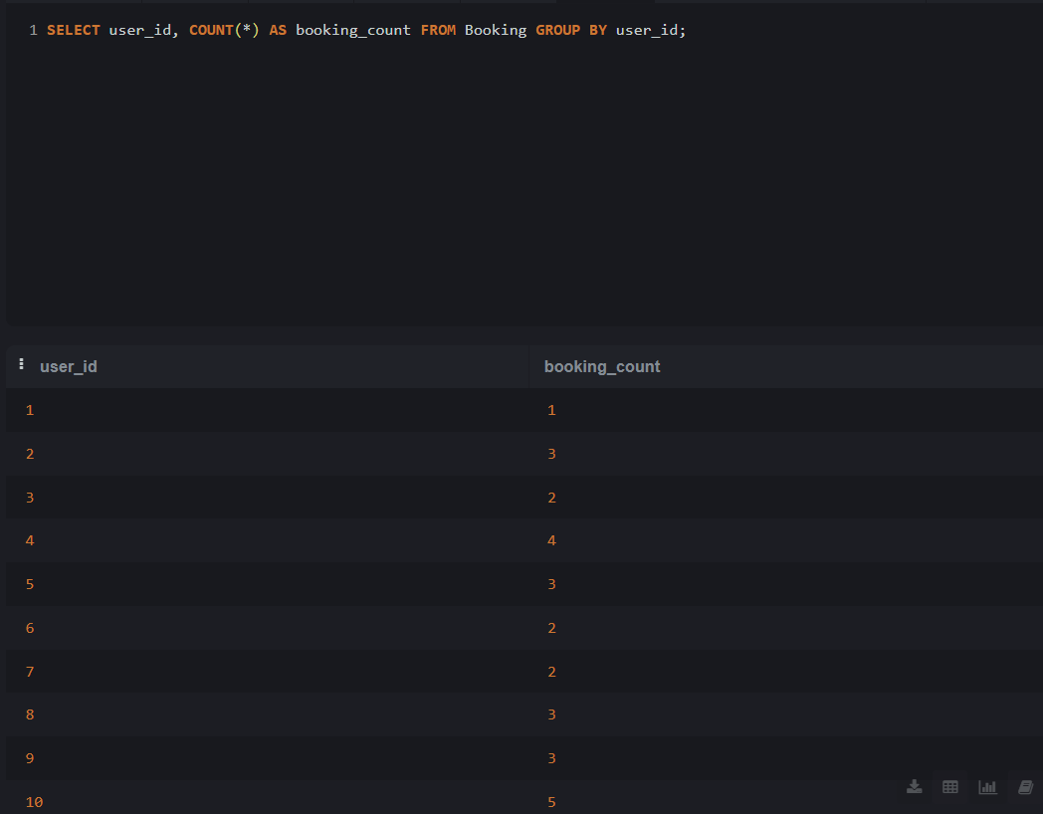

Lab 11.1.2: SELECT COUNT(*) FROM FoodItems WHERE is_combo = 1;

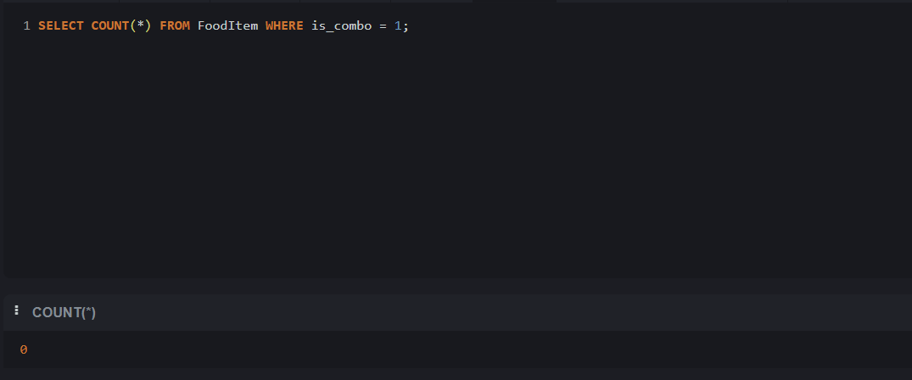

Lab 11.2.1: SELECT user_id, SUM(total_amount) AS total_spent FROM Bookings GROUP BY user_id;

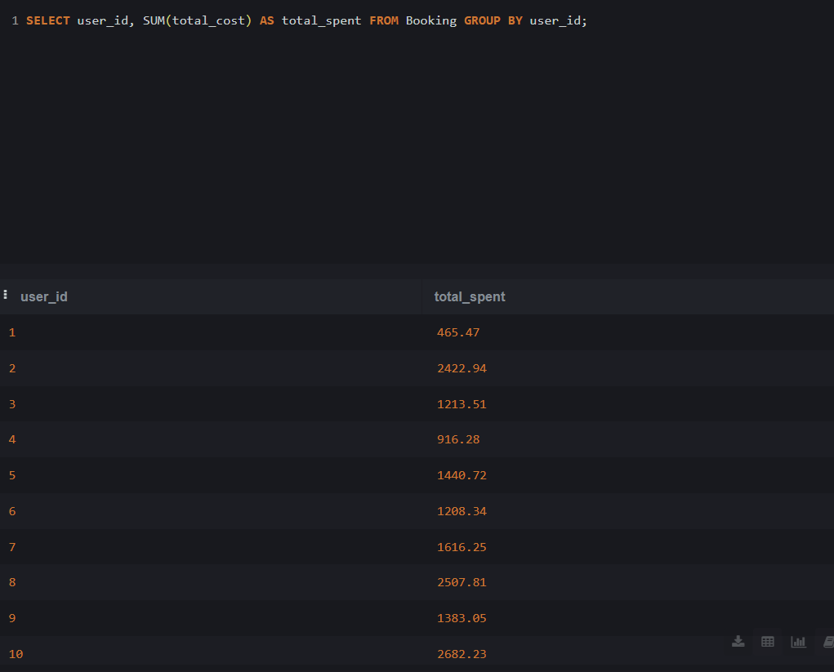

Lab 11.2.2: SELECT user_id, SUM(amount) AS total_loyalty_points FROM LoyaltyPointsTransactions GROUP BY user_id;

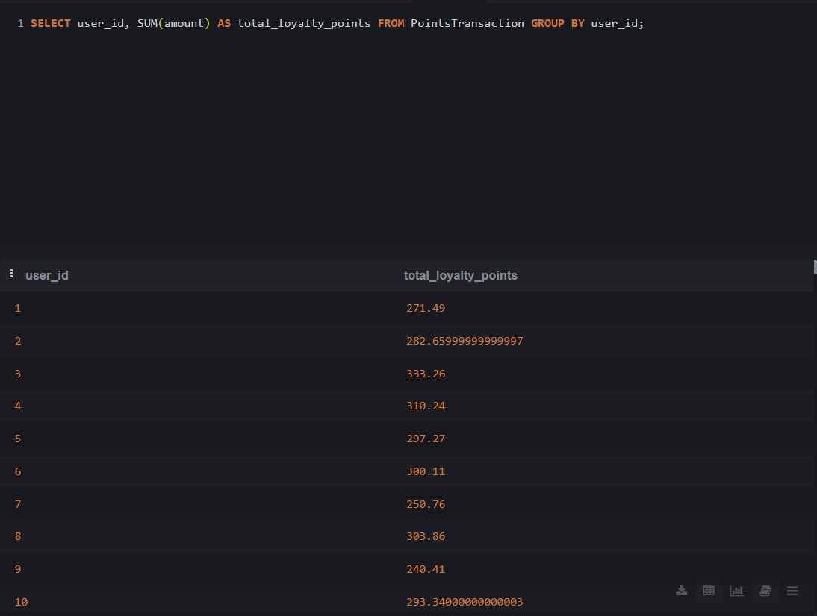

Lab 11.3.1: SELECT genre, AVG(rating) AS avg_rating FROM Movies GROUP BY genre;

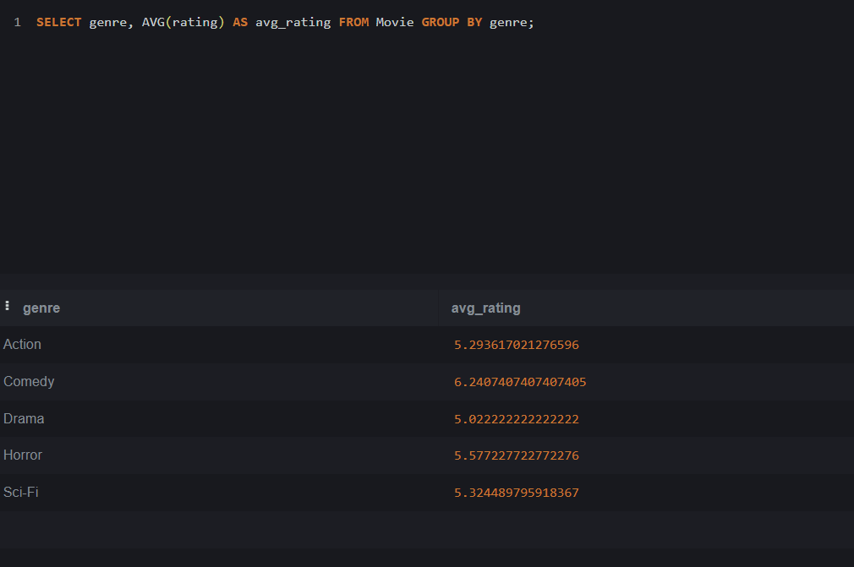

Lab 11.3.2: SELECT AVG(points_used) AS avg_points_used FROM LoyaltyPointsTransactions;

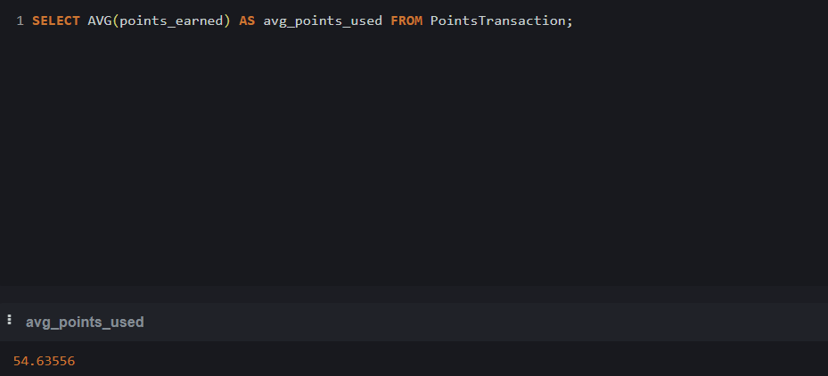

Lab 11.4.1: SELECT genre, MAX(rating) AS highest, MIN(rating) AS lowest FROM Movies GROUP BY genre;

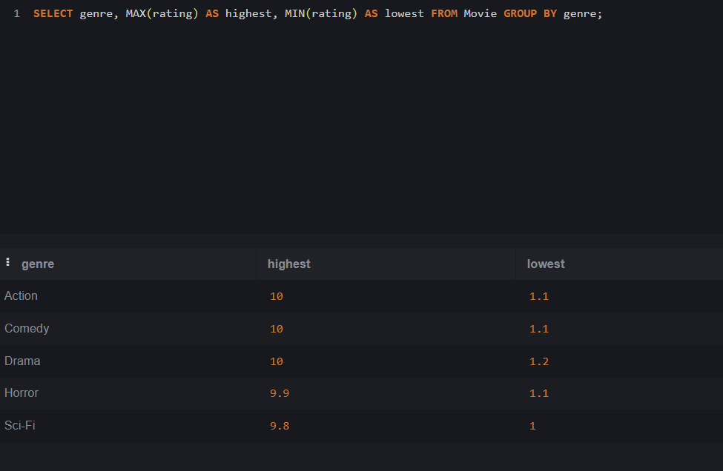

Lab 11.4.2: SELECT screen_id, MIN(show_datetime) AS earliest, MAX(show_datetime) AS latest FROM Shows GROUP BY screen_id;

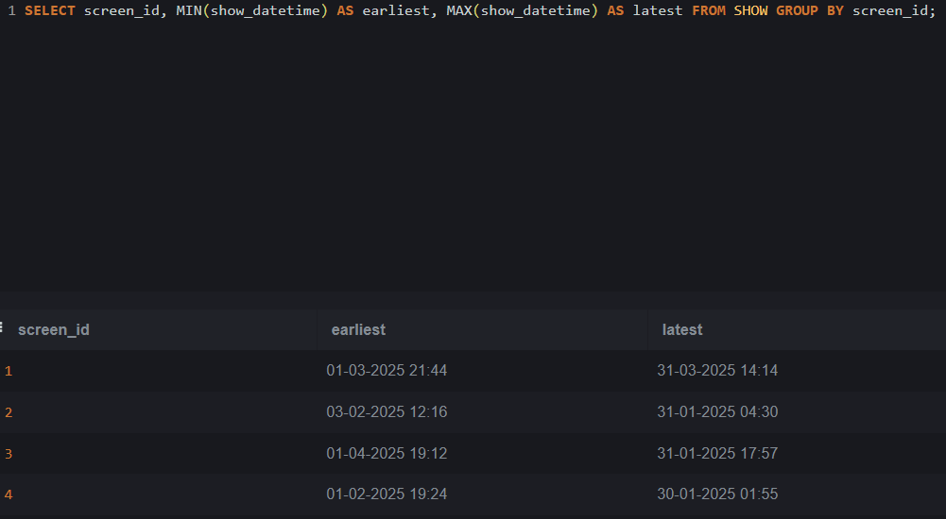

Topic 12: GROUP BY with Aggregate Functions

Lab 12.1: SELECT movie_id, COUNT(*) AS show_count FROM Shows GROUP BY movie_id;

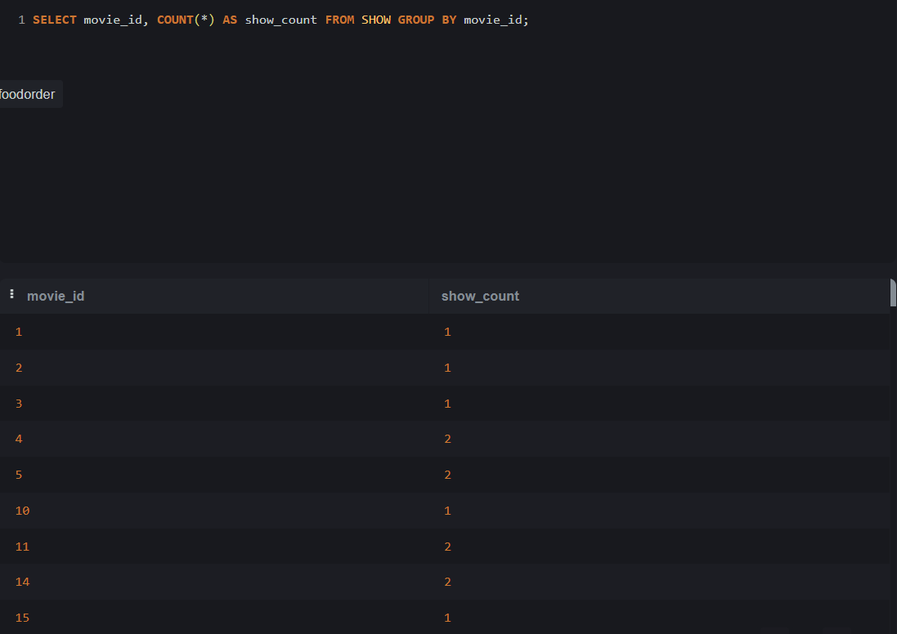

Lab 12.2: SELECT user_id, COUNT(*) AS transaction_count FROM LoyaltyPointsTransactions WHERE amount > 60 GROUP BY user_id;

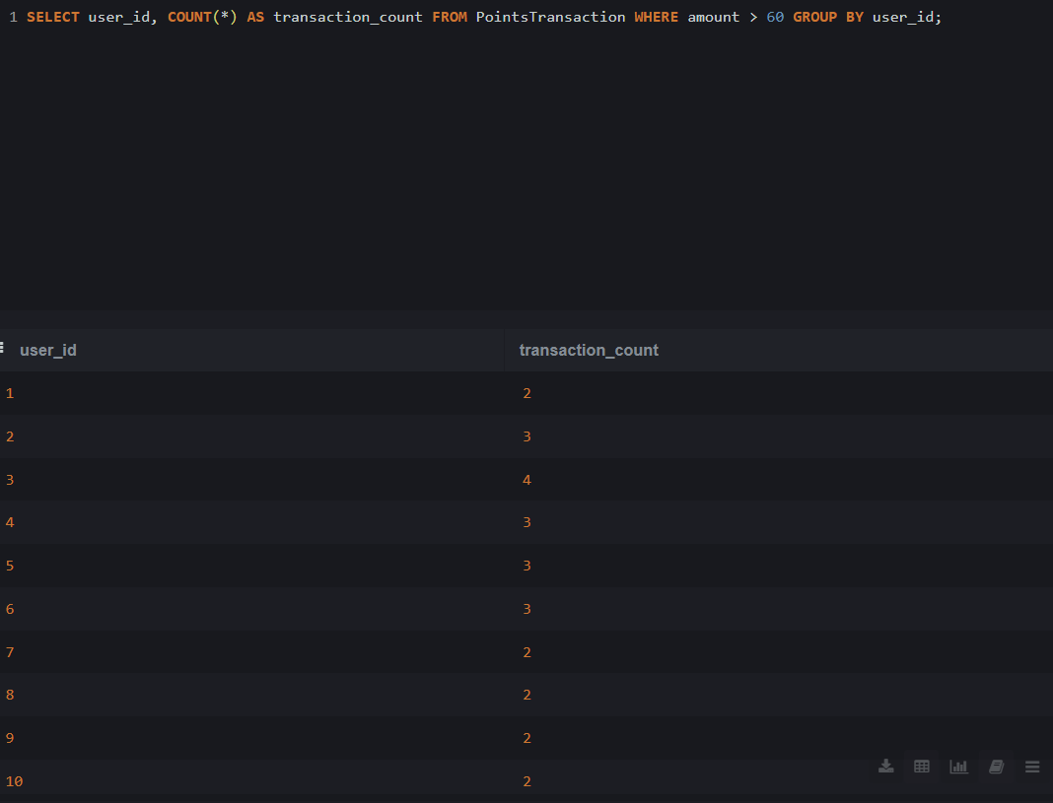

Topic 13: GROUP BY with HAVING Clause

Lab 13.1: SELECT screen_id, COUNT(*) AS show_count FROM Shows GROUP BY screen_id HAVING COUNT(*) > 1;

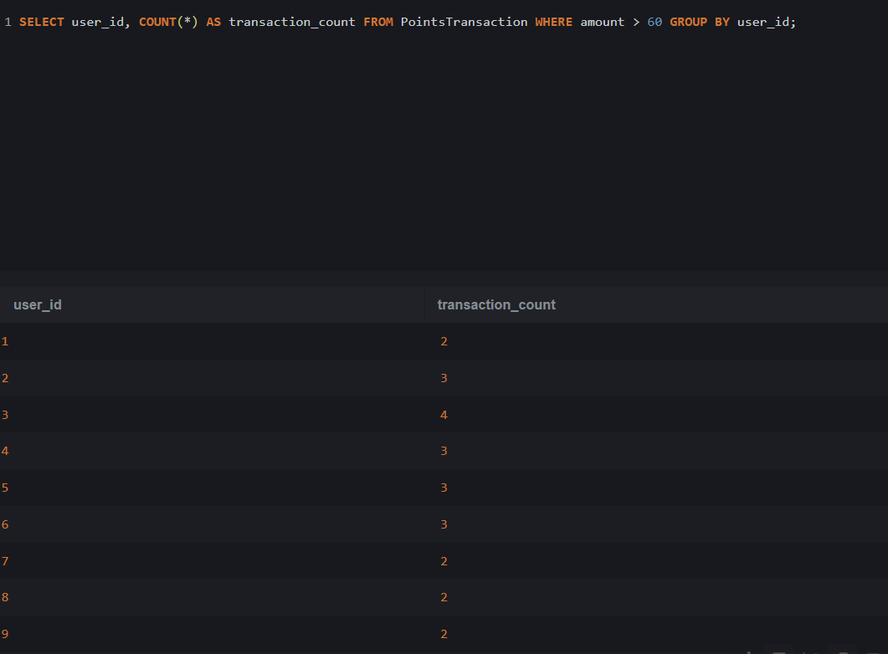

Lab 13.2: SELECT status, COUNT(*) AS movie_count FROM Movies GROUP BY status HAVING COUNT(*) > 2;

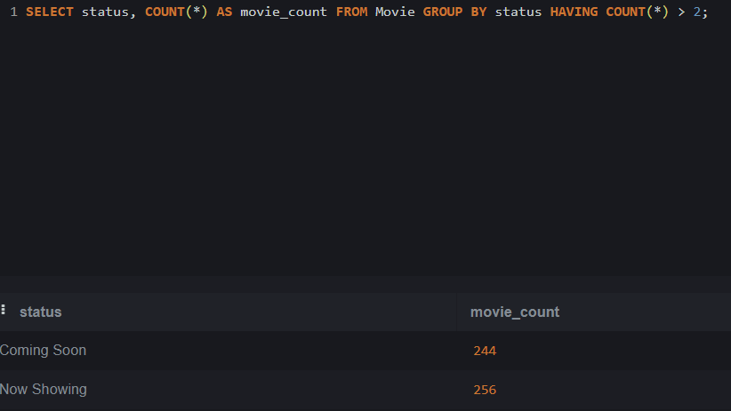

Topic 14: GROUP BY with WHERE and ORDER BY

Lab 14.1: SELECT user_id, SUM(total_amount) AS total_spent FROM Bookings WHERE total_amount > 300 GROUP BY user_id ORDER BY total_spent DESC;

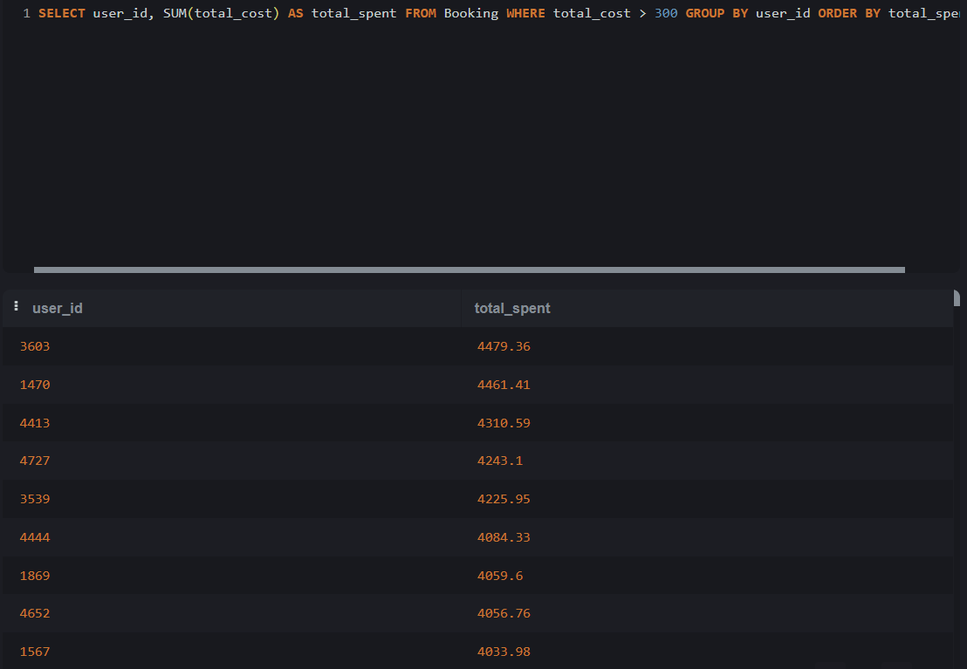

Lab 14.2: SELECT user_id, COUNT(*) AS transaction_count FROM LoyaltyPointsTransactions WHERE amount > 50 GROUP BY user_id HAVING COUNT(*) > 3;

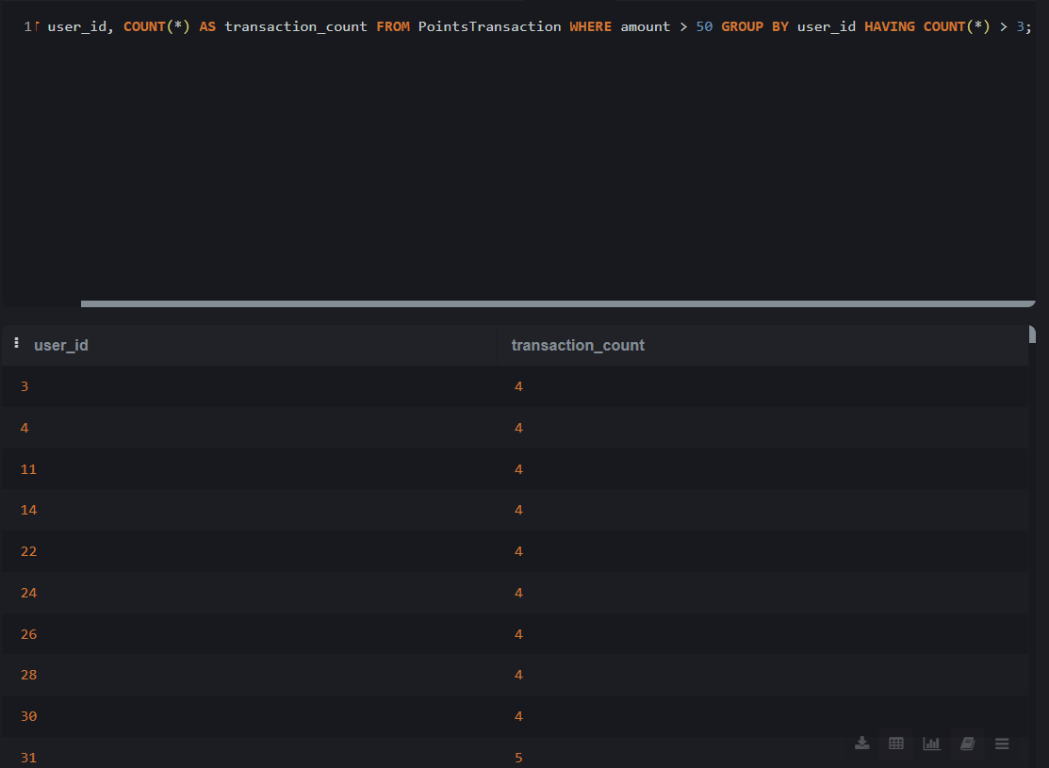

Topic 15: GROUP BY Multiple Columns

Lab 15.1: SELECT user_id, show_id, COUNT(*) AS booking_count FROM Bookings GROUP BY user_id, show_id;

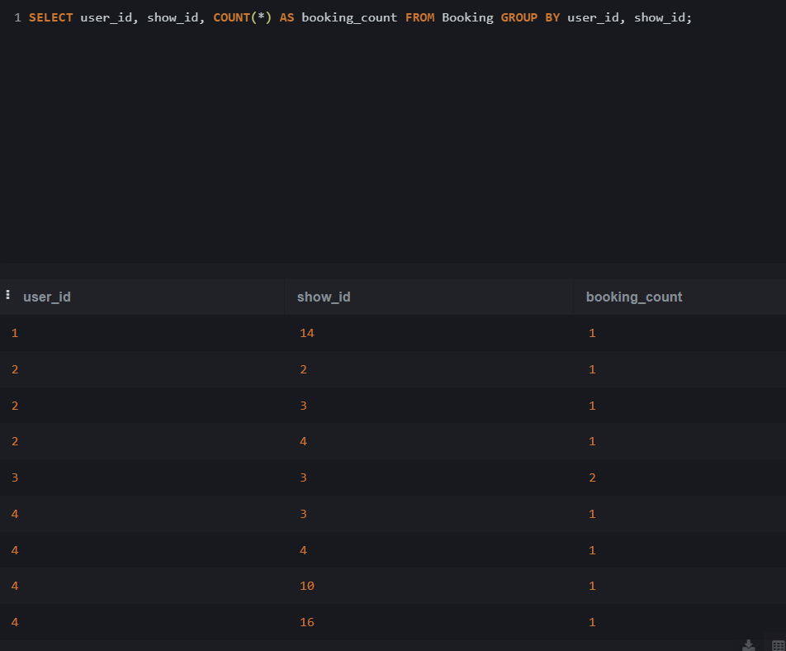

Lab 15.2: SELECT screen_id, movie_id, COUNT(*) AS show_count FROM Shows GROUP BY screen_id, movie_id;

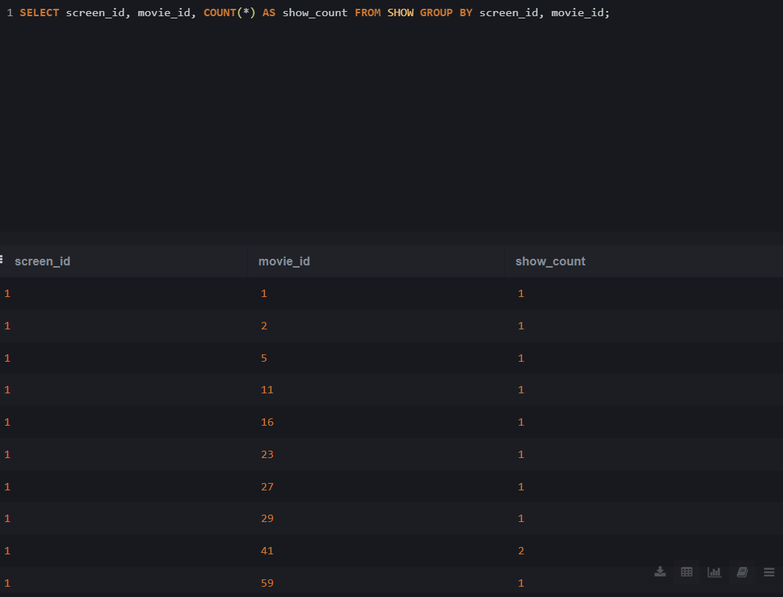

Topic 16: INNER JOIN

Lab 16.1: SELECT m.title, c.name, mc.role FROM Movies m INNER JOIN MovieCast mc ON m.id = mc.movie_id INNER JOIN Cast c ON mc.cast_id = c.id;

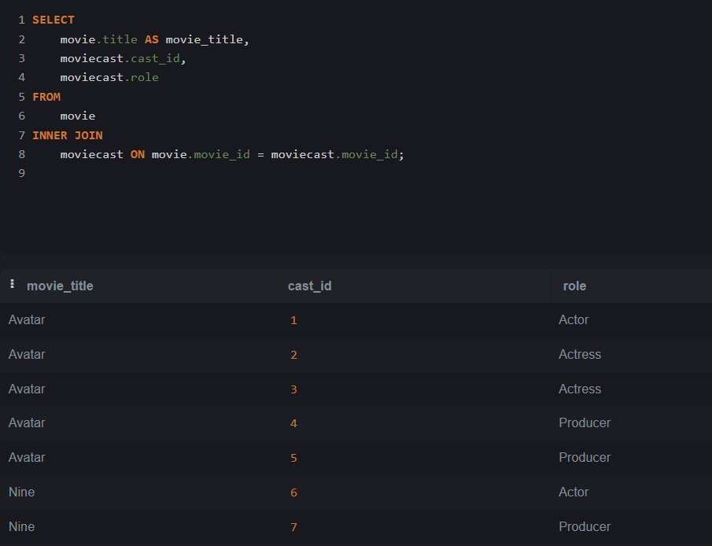

Lab 16.2: SELECT

movie.title AS movie_title,

screen.screen_name,

show.show_datetime

FROM

show

INNER JOIN

movie ON show.movie_id = movie.movie_id

INNER JOIN

screen ON show.screen_id = screen.screen_id;

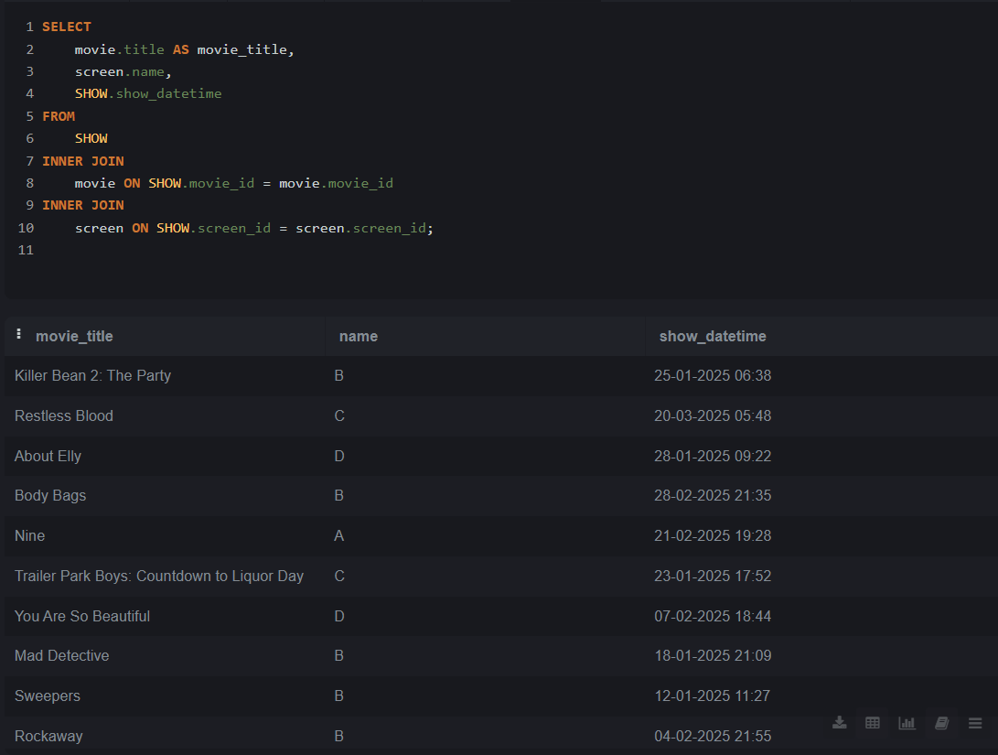

Topic 17: LEFT JOIN

Lab 17.1 SELECT

movie.title AS movie_title,

review.content

FROM

movie

LEFT JOIN

review ON movie.movie_id = review.movie_id;

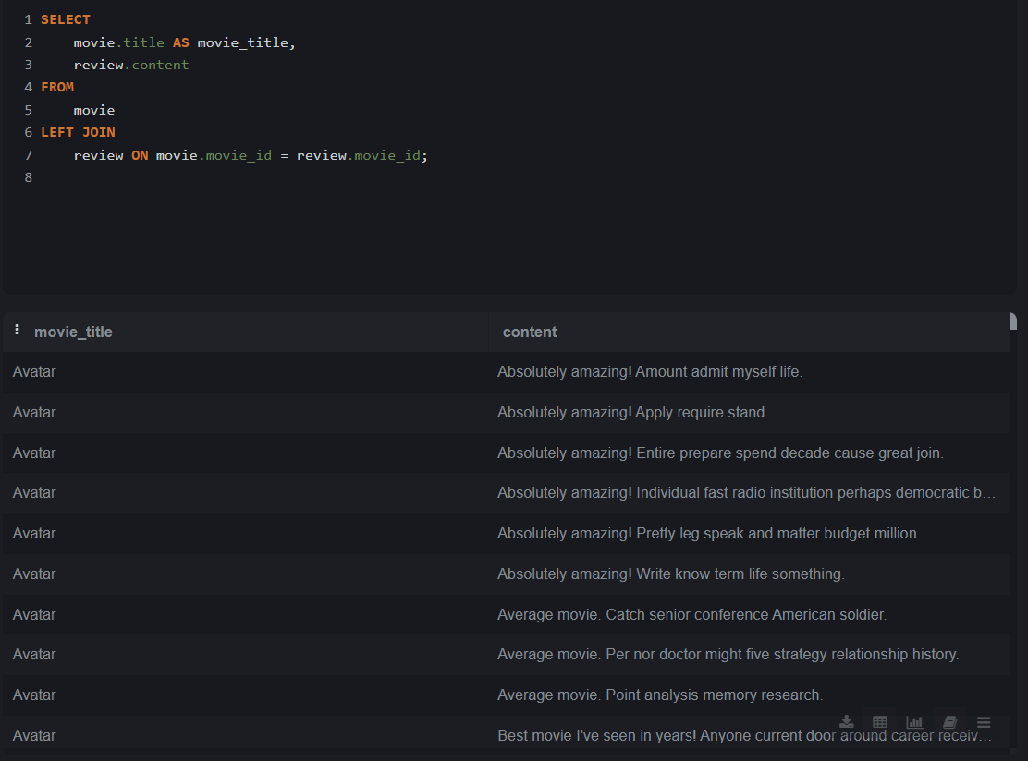

Lab 17.2: SELECT

movie.title AS movie_title,

moviecast.cast_name

FROM

movie

LEFT JOIN

moviecast ON movie.movie_id = moviecast.movie_id;

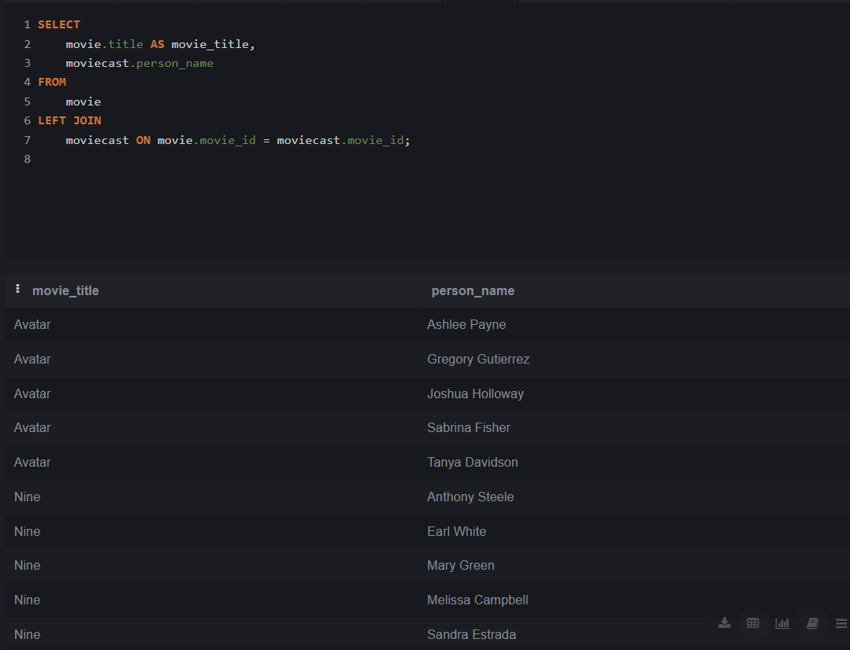

Topic 18: RIGHT JOIN

Lab 18.1: SELECT

seat.seat_id,

seat.seat_number,

showseat.show_id

FROM

seat

LEFT JOIN

showseat ON seat.seat_id = showseat.seat_id;

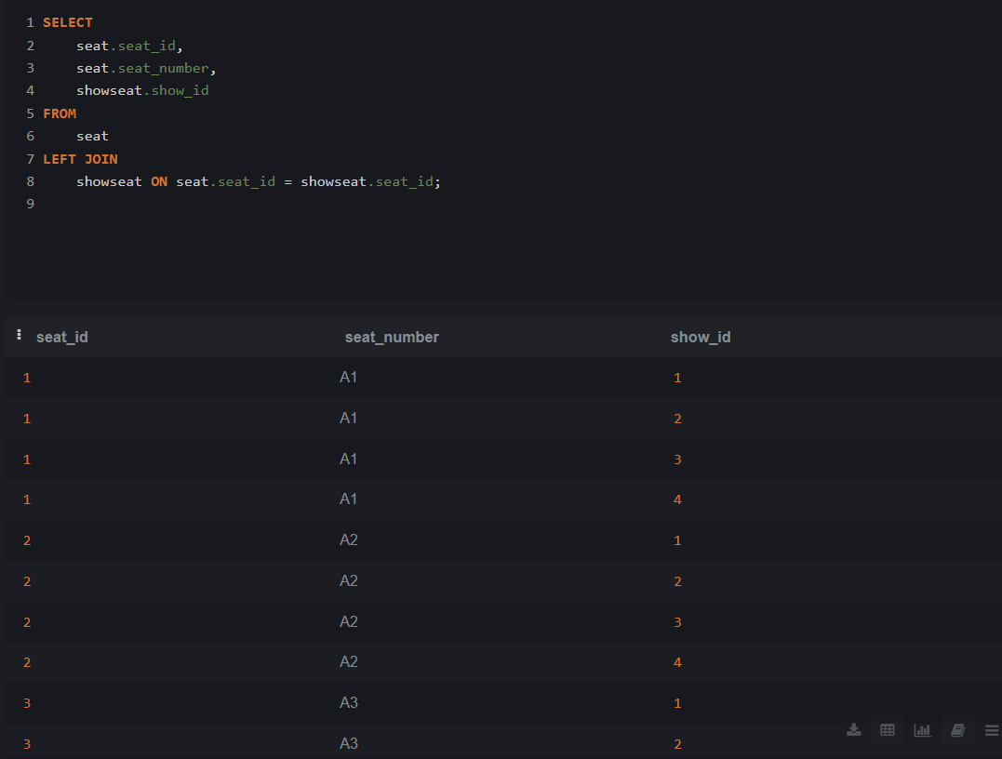Lab 18.2: SELECT

booking.booking_id,

user.name AS user_name,

booking.booking_datetime,

movie.title AS movie_title

FROM

booking

INNER JOIN

user ON booking.user_id = user.user_id

INNER JOIN

ticket ON booking.booking_id = ticket.booking_id

INNER JOIN

show ON ticket.show_id = show.show_id

INNER JOIN

movie ON show.movie_id = movie.movie_id

LEFT JOIN

payment ON booking.booking_id = payment.booking_id;

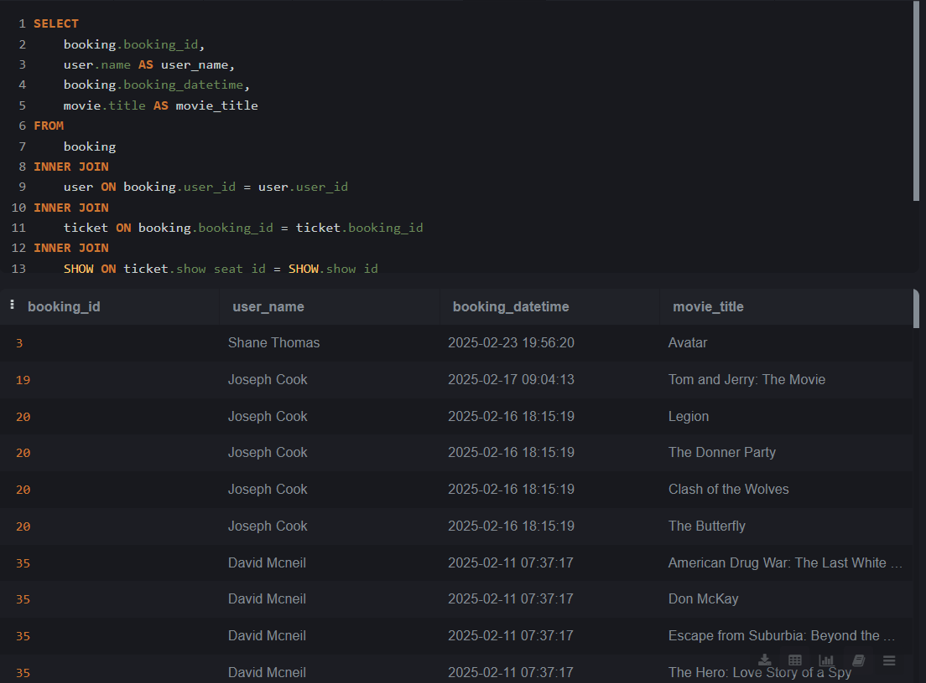

Topic 19: FULL OUTER JOIN

Lab 19.1: SELECT

movie.title AS movie_title,

review.review_content

FROM

movie

LEFT JOIN

review ON movie.movie_id = review.movie_id

UNION

SELECT

movie.title AS movie_title,

review.review_content

FROM

review

LEFT JOIN

movie ON review.movie_id = movie.movie_id;

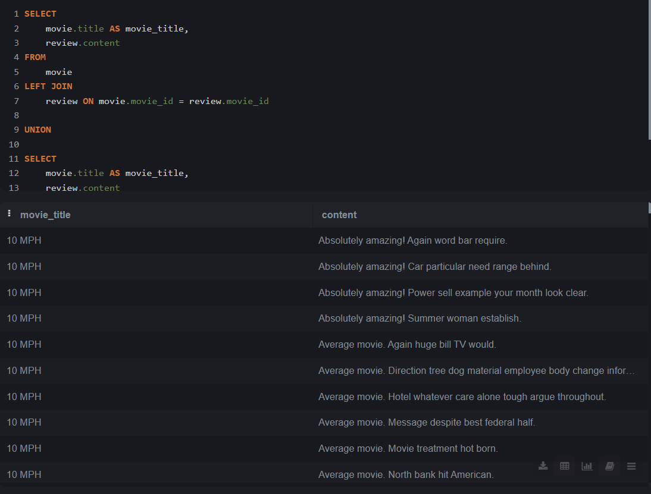Lab 19.2: SELECT

user.name AS user_name,

ticket.ticket_id

FROM

user

LEFT JOIN

booking ON user.user_id = booking.user_id

LEFT JOIN

ticket ON booking.booking_id = ticket.booking_id

UNION

SELECT

user.name AS user_name,

ticket.ticket_id

FROM

ticket

LEFT JOIN

booking ON ticket.booking_id = booking.booking_id

LEFT JOIN

user ON booking.user_id = user.user_id; 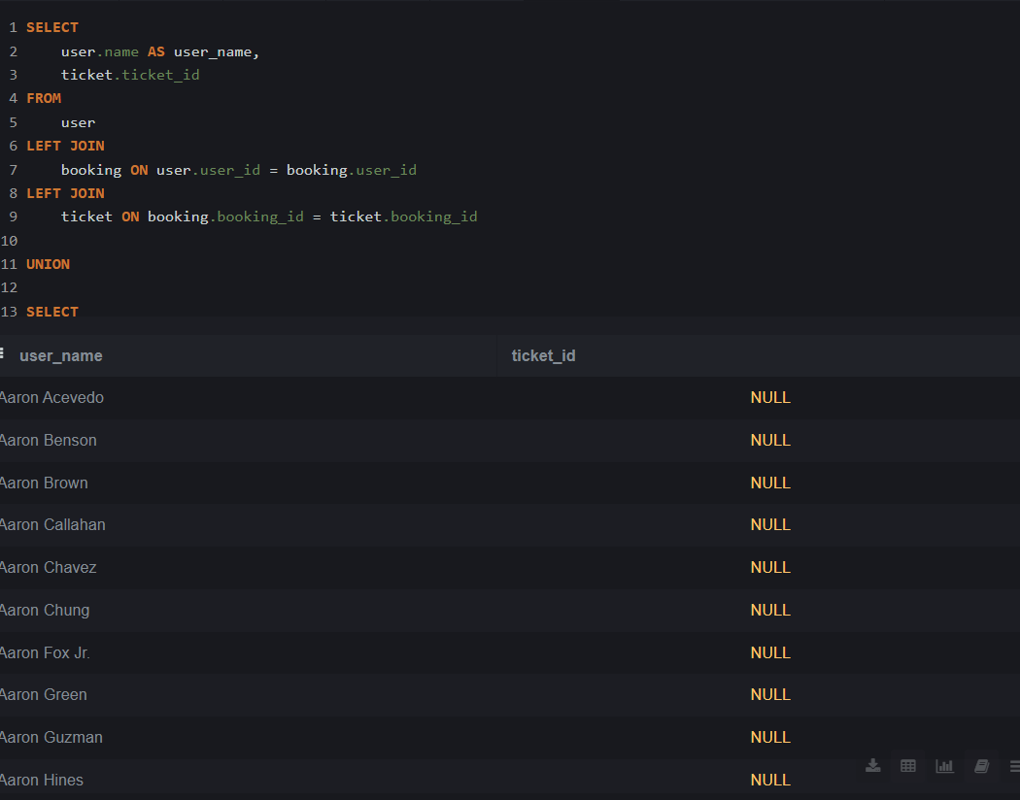

Topic 20: JOIN with Multiple Tables

Lab 20.1: SELECT

fooditem.name AS food_item_name,

fooditemsize.size_name,

foodorderitem.quantity,

(foodorderitem.quantity * fooditemsize.price) AS total_cost

FROM

foodorderitem

INNER JOIN

fooditemsize ON foodorderitem.fooditemsize_id = fooditemsize.fooditemsize_id

INNER JOIN

fooditem ON fooditemsize.fooditem_id = fooditem.fooditem_id

INNER JOIN

foodorder ON foodorderitem.foodorder_id = foodorder.foodorder_id;

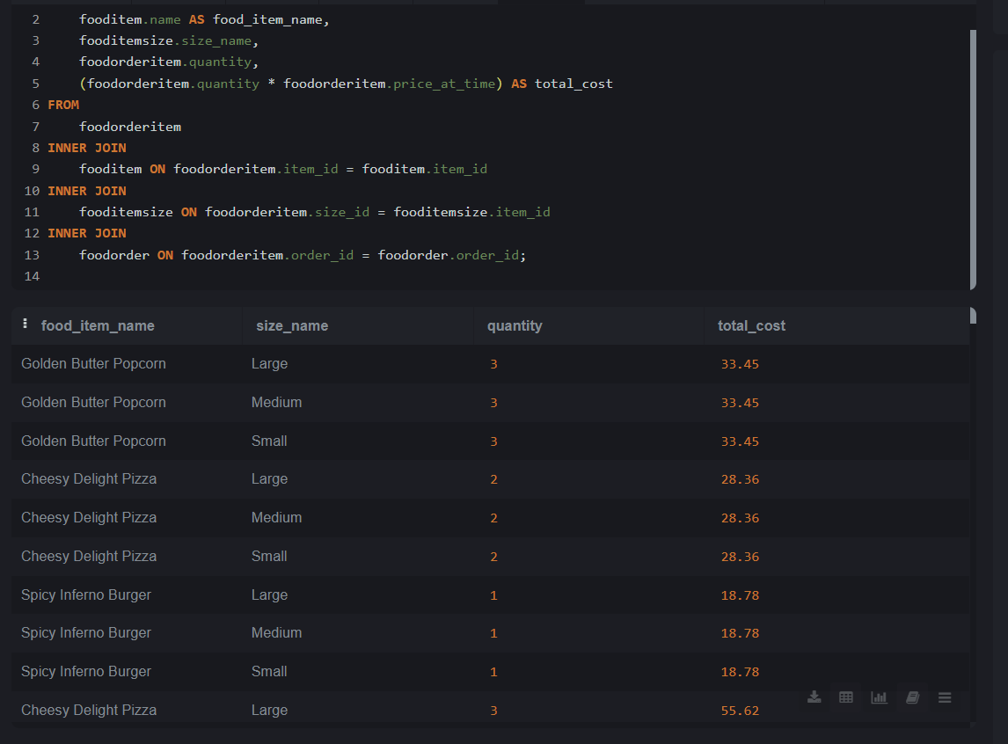Lab 20.2 SELECT

fooditem.name AS food_item_name,

foodorderitem.quantity,

fooditemsize.rate

FROM

foodorderitem

INNER JOIN

fooditemsize ON foodorderitem.item_id = fooditemsize.item_id

INNER JOIN

fooditem ON fooditemsize.item_id = fooditem.item_id;

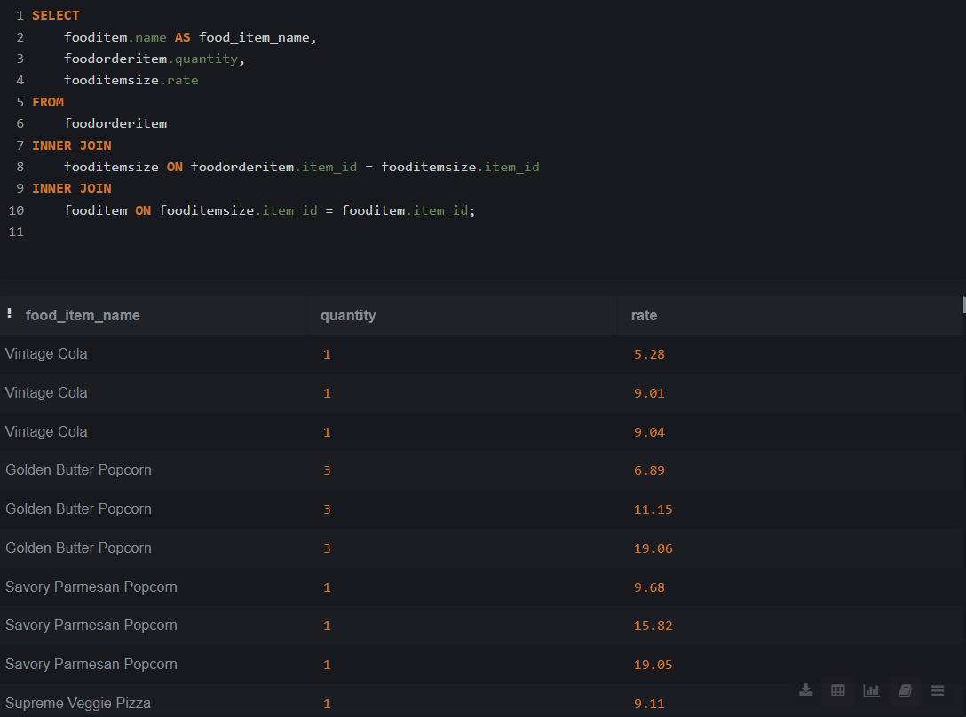

Topic 21: JOIN with GROUP BY and Aggregate Functions

Lab 21.1: SELECT m.title, COUNT(b.id) AS total_bookings FROM Movies m JOIN Bookings b ON m.id = b.movie_id GROUP BY m.title;

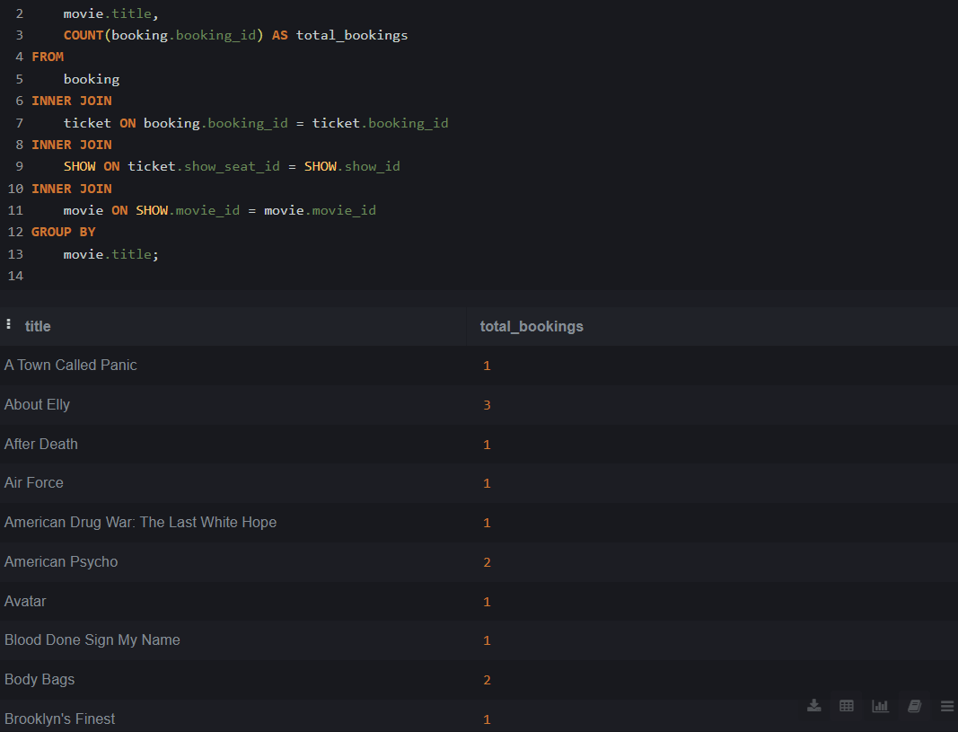

Lab 21.2: SELECT

screen.name,

COUNT(showseat.seat_id) AS seat_count

FROM

showseat

INNER JOIN

show ON showseat.show_id = show.show_id

INNER JOIN

screen ON show.screen_id = screen.screen_id

GROUP BY

screen.name;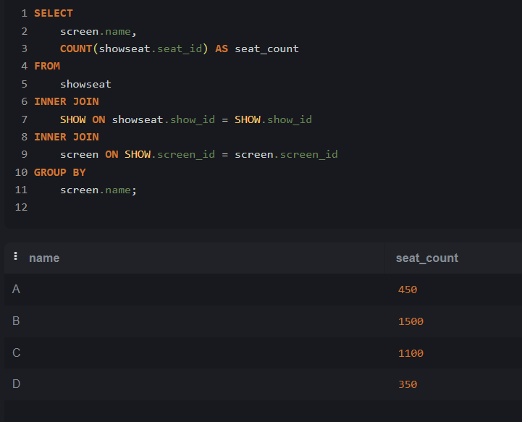

Topic 22: JOIN with WHERE and HAVING Clause

Lab 22.1: SELECT

movie.title,

COUNT(review.review_id) AS review_count

FROM

movie

INNER JOIN

review ON movie.movie_id = review.movie_id

WHERE

movie.rating > 7.5

GROUP BY

movie.title

HAVING

COUNT(review.review_id) > 3;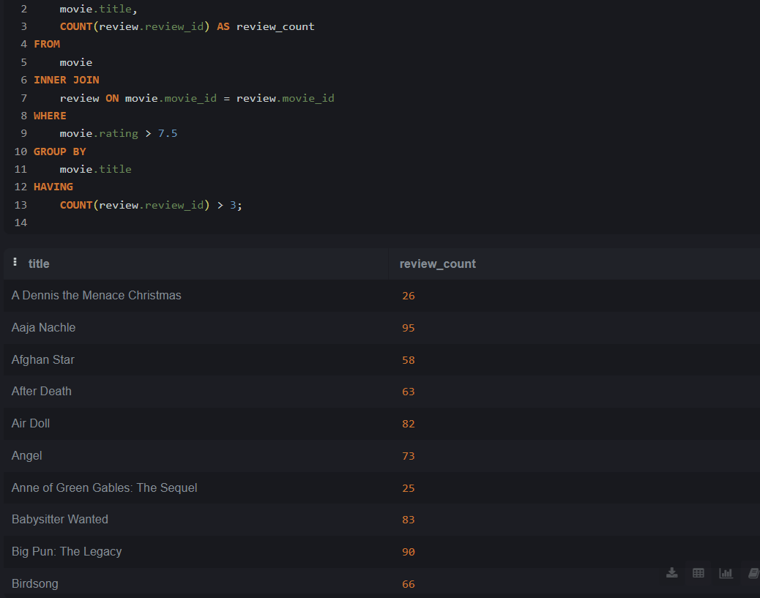

Lab 22.2: SELECT

movie.title,

screen.name,

show.show_datetime

FROM

show

INNER JOIN

movie ON show.movie_id = movie.movie_id

INNER JOIN

screen ON show.screen_id = screen.screen_id

WHERE

show.show_datetime > '2025-05-01';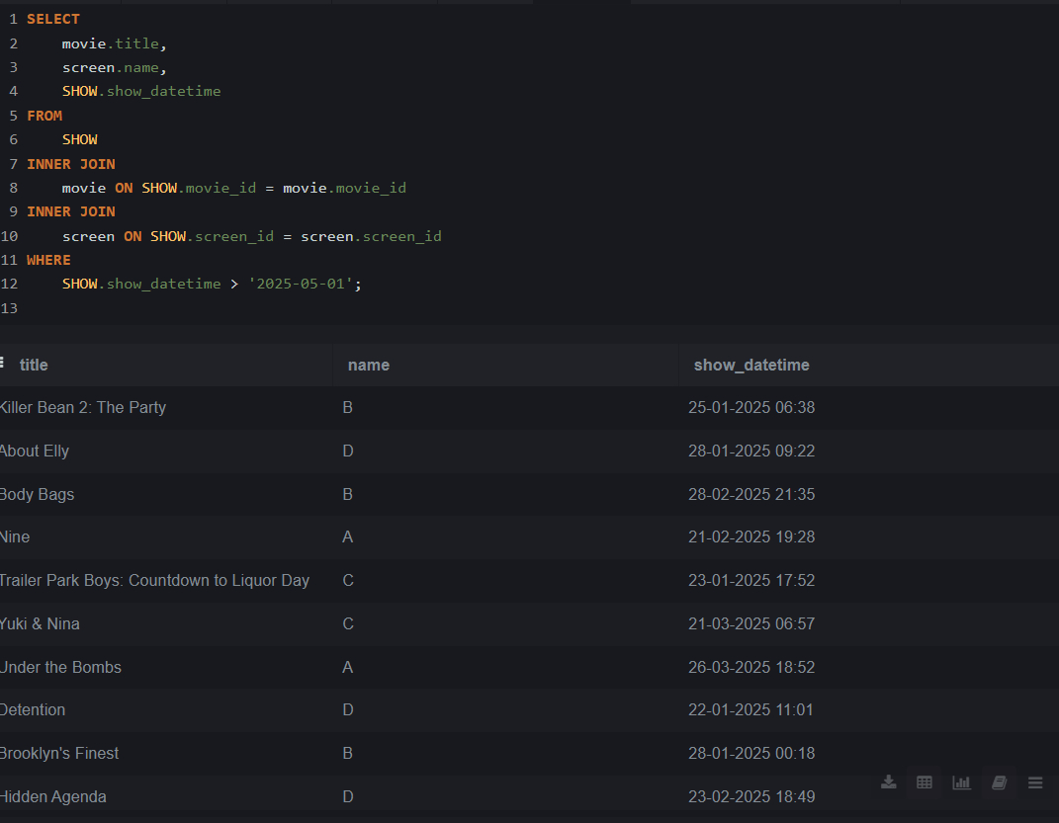

Topic 23: JOIN with ORDER BY and LIMIT

Lab 23.1: SELECT

fooditem.name,

fooditemsize.rate

FROM

fooditemsize

INNER JOIN

fooditem ON fooditemsize.item_id = fooditem.item_id

ORDER BY

fooditemsize.rate DESC

LIMIT 10;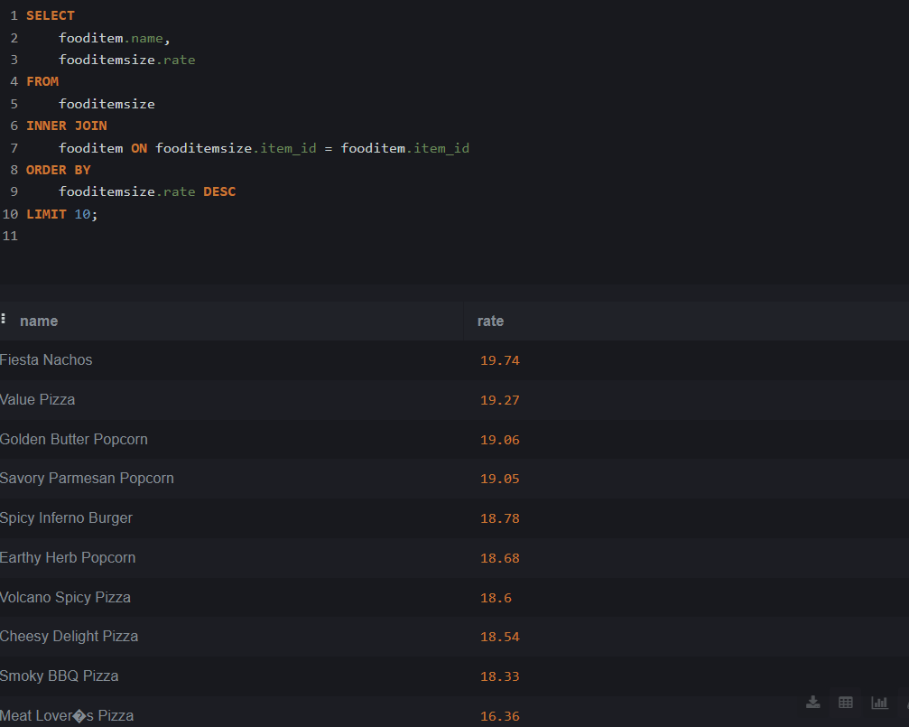

Lab 23.2 SELECT

user.name AS user_name,

booking.total_cost

FROM

booking

INNER JOIN

user ON booking.user_id = user.user_id

ORDER BY

booking.booking_datetime DESC

LIMIT 3;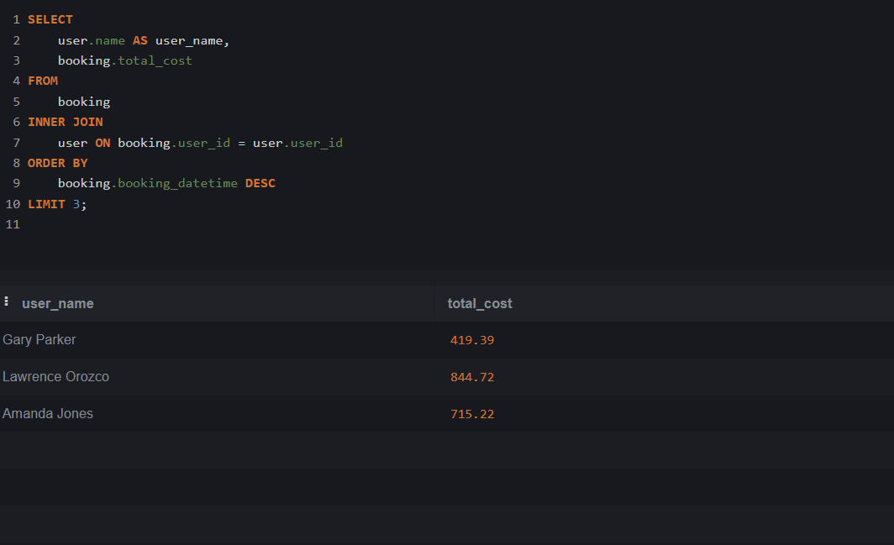

Topic 24: JOIN with Aggregate + WHERE + Multiple Conditions

Lab 24.1 SELECT

screen.screen_id,

SUM(fooditemsize.rate * foodorderitem.quantity) AS total_food_cost

FROM

foodorderitem

INNER JOIN

foodorder ON foodorderitem.order_id = foodorder.order_id

INNER JOIN

booking ON foodorder.booking_id = booking.booking_id

INNER JOIN

ticket ON booking.booking_id = ticket.booking_id

INNER JOIN

show ON ticket.ticket_id = show.show_id

INNER JOIN

screen ON show.screen_id = screen.screen_id

INNER JOIN

fooditemsize ON foodorderitem.item_id = fooditemsize.item_id

GROUP BY

screen.screen_id

HAVING

total_food_cost > 30;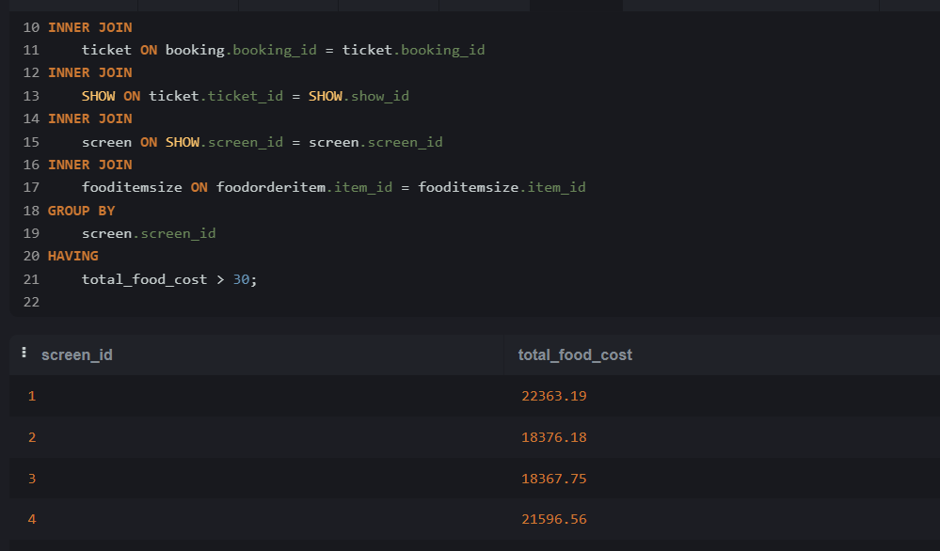

Lab 24.2: SELECT u.name, SUM(b.total_amount) AS total_booking_cost FROM Users u JOIN Bookings b ON u.id = b.user_id GROUP BY u.name HAVING SUM(b.total_amount) > 50;

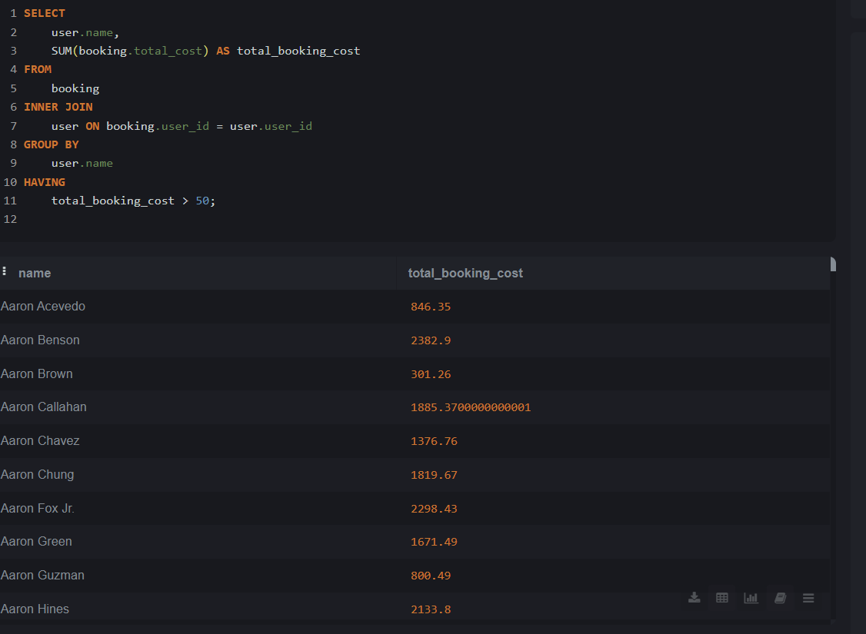

Topic 25: Complex JOINs involving 3+ Tables

Lab 25.1 SELECT

user.name AS user_name,

SUM(fooditemsize.rate * foodorderitem.quantity) AS total_spent_on_food

FROM

foodorder

INNER JOIN

booking ON foodorder.booking_id = booking.booking_id

INNER JOIN

user ON booking.user_id = user.user_id

INNER JOIN

foodorderitem ON foodorder.order_id = foodorderitem.order_id

INNER JOIN

fooditemsize ON foodorderitem.item_id = fooditemsize.item_id

GROUP BY

user.name

HAVING

total_spent_on_food > 100;

